MEDCARE SECURE HEALTHCARE APPLICATION
Modular Assignment 7 | Healthcare Solution
Md Habib Ahmed | IHC – Cloud Development | November 2026

1. Objective and scope
MedCare is an AWS-based healthcare operations prototype developed to demonstrate secure application deployment, patient-data integration, appointment scheduling, analytics, and operational testing. The solution uses synthetic records rather than real patient information. The implemented scope includes an EC2-hosted Flask dashboard and Doctor Scheduling API, S3 datasets, Lambda ETL, DynamoDB booking persistence, IAM permissions, restricted application access, and repeatable workload and recovery tests in Stockholm (eu-north-1).

2. Architecture and deployment
The application runs on one Ubuntu 24.04 EC2 instance. Nginx reverse-proxies requests to separate Gunicorn-managed Flask services: the dashboard on 127.0.0.1:8000 and Doctor Scheduling API on 127.0.0.1:8001. Authorized dashboard users connect through an SSH tunnel to Nginx HTTPS on the instance loopback address; the certificate is self-signed and Nginx applies Basic Authentication. The Doctor API additionally requires a bearer token. S3 stores raw and processed healthcare datasets, Lambda performs the ETL, and DynamoDB holds appointment bookings. The dashboard reads processed S3 analytics and current booking availability from DynamoDB.
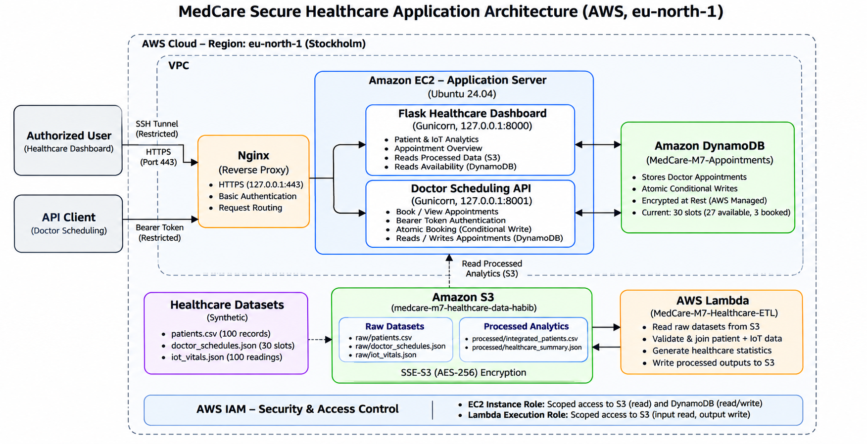
Figure 1. MedCare implemented AWS architecture in eu-north-1.

3. Application and synthetic datasets
The raw inputs are patients.csv (100 synthetic patient records), doctor_schedules.json (30 consultation slots across five doctors), and iot_vitals.json (100 simulated vital readings). Lambda validates identifiers and joins patient records with vital readings, producing processed/integrated_patients.csv and processed/healthcare_summary.json in S3. The dashboard presents patient counts, diagnosis distribution, appointment activity by date, doctor availability, and recent vital readings. Its booking counts are refreshed from DynamoDB rather than taken from the older S3 summary snapshot.
The API exposes /health, /doctors, /doctors/<doctor_id>, and POST /appointments. Booking checks the patient and consultation slot, then uses a DynamoDB conditional PutItem operation to prevent two clients from reserving the same slot.

4. Data integration and monitoring
The Python 3.13 Lambda function MedCare-M7-Healthcare-ETL reads the three raw objects from the S3 bucket medcare-m7-healthcare-data-habib, validates patient references and duplicate identifiers, computes healthcare statistics, and writes the integrated CSV and JSON summary back to the processed/ prefix. S3 outputs use SSE-S3 (AES-256) encryption. Lambda does not read DynamoDB; the EC2 applications perform the live appointment queries. Evidence E04–E06 documents the S3 storage and ETL outputs.
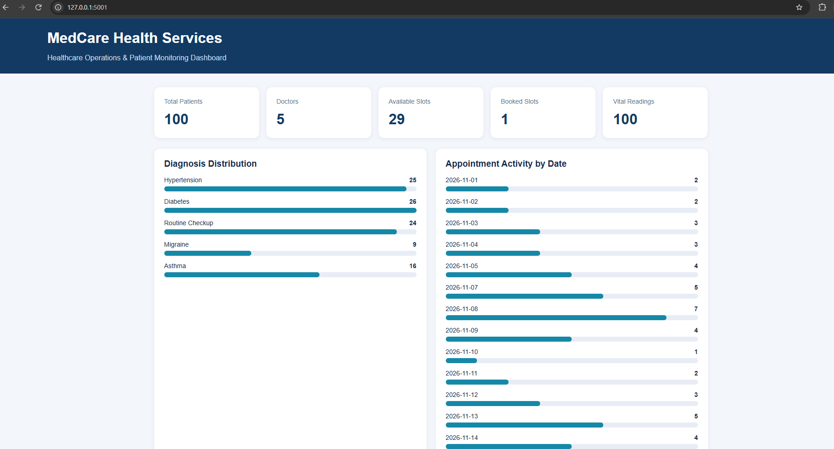
Figure 2. Healthcare dashboard evidence from the deployed application.

5. Security and access control
Application access is restricted: the Nginx HTTPS listener is bound to 127.0.0.1:443 and reached through SSH port forwarding, not exposed as a publicly trusted HTTPS website. Nginx Basic Authentication protects dashboard access; a bearer token protects scheduling API operations. Gunicorn binds both Flask applications to localhost. The EC2 instance role has scoped S3-read and DynamoDB permissions, while the Lambda execution role has scoped S3 raw-object read and processed-object write permissions. DynamoDB uses default encryption at rest. The implementation is an academic prototype, not a HIPAA-certified production system.
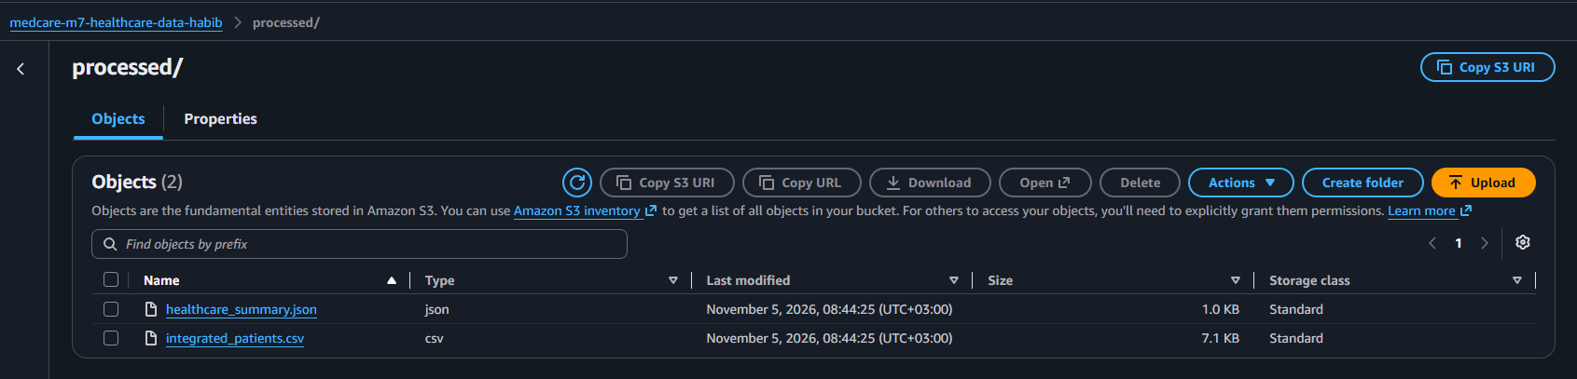
Figure 3. Selected security or functional verification evidence.

6. Testing method and performance evaluation
Functional tests verified dashboard responses, authenticated API access, invalid-token rejection, valid appointment creation, DynamoDB persistence, and conflict handling for duplicate booking attempts. In a simultaneous five-request booking test, one request succeeded with HTTP 201 while four received HTTP 409. A separate concurrent workload simulation used 10 workers to send 30 requests. All 30 succeeded with no recorded failures; average response latency was 2.215 seconds and total test duration was 7.750 seconds.
Observed metric | Verified result
Workload requests | 30
Concurrent workers | 10
Successful requests | 30 / 30 (100%)
Average response latency | 2.215 seconds
Total workload duration | 7.750 seconds
Booking conflict test | 1 × HTTP 201; 4 × HTTP 409
Current appointment status | 30 slots; 27 available; 3 booked
These results demonstrate a limited workload simulation on one EC2 server; they do not establish an Auto Scaling Group, load balancer, multi-Availability-Zone deployment, or sustained production throughput.
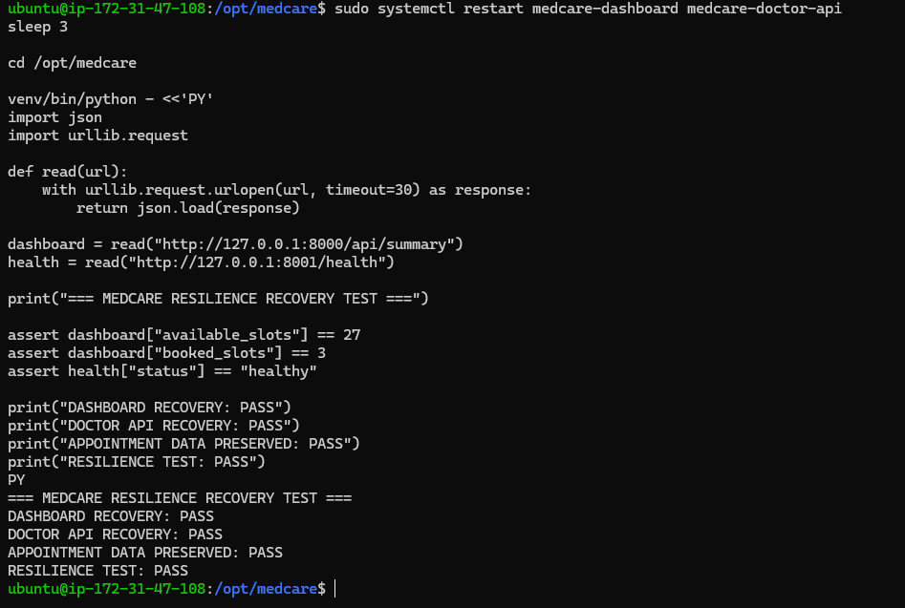
Figure 4. Selected workload or operational test evidence.

7. Availability and operational recovery
The dashboard and API run as systemd services. Both were restarted during a controlled recovery check and returned to service, while the three appointment bookings remained stored in DynamoDB. This verifies process recovery and persistent booking state under the tested conditions. It is not a multi-instance failover test. Evidence E08–E11 records persistence, concurrent workload, service recovery, and final dashboard verification.

8. Cost and resource efficiency
The prototype uses a single EC2 instance rather than an always-on multi-instance cluster. S3 provides object storage, Lambda processes datasets on demand, and DynamoDB maintains appointment records. This keeps the architecture proportionate to an academic workload. AWS billing depends on EC2 running hours, attached storage, S3 usage, Lambda requests, DynamoDB capacity, and data transfer. No project-specific verified monthly invoice or pricing estimate is asserted. After university evidence and submission are complete, unused AWS resources should be stopped or deleted to avoid further charges.

9. Conclusions and reproducibility
The implemented MedCare prototype integrates synthetic healthcare datasets, S3/Lambda ETL, a Flask monitoring dashboard, a protected scheduling API, and persistent DynamoDB bookings. Verified tests demonstrate conditional booking conflict prevention, 30 successful concurrent workload requests, and application recovery with appointment state preserved. The accompanying repository contains the Python application, Lambda source, synthetic datasets, architecture diagram, configuration and deployment documentation, and evidence E01–E11. Reproduction requires AWS resources, appropriate IAM permissions, and locally supplied authentication secrets; credentials and private keys must not be committed.
Evidence and setup: README.md, docs/architecture/MedCare-M7-Architecture.png, and docs/evidence/E01–E11 in the accompanying GitHub repository.

